**PROJECT GOALS:**

* Identify the most popular routes
* Determine peak travel times
* Analyze revenue from different ticket types & classes
* Diagnose on-time performance and contributing factors

**METRICS:**

* **Total Routes: The combination of departure stations and arrival destinations.**
* **Total Revenue:** The sum of the price of each ticket, including refunded tickets.
* **Revenue Without Refund:** Revenue excluding refunded tickets.
* **Total Tickets:** The total number of tickets sold, including refunded tickets.
* **On-time Ratio:** The ratio of tickets on-time divided by total tickets.
* **Refund Ratio:** The ratio of refunded tickets divided by total tickets.

**DASHBOARD EXPLANATION:**

**Instructions:** Select the pages you want to view and use the filters in the left panel to focus on a specific time frame, departure station, or arrival destination.

**1. OVERVIEW PAGE:**

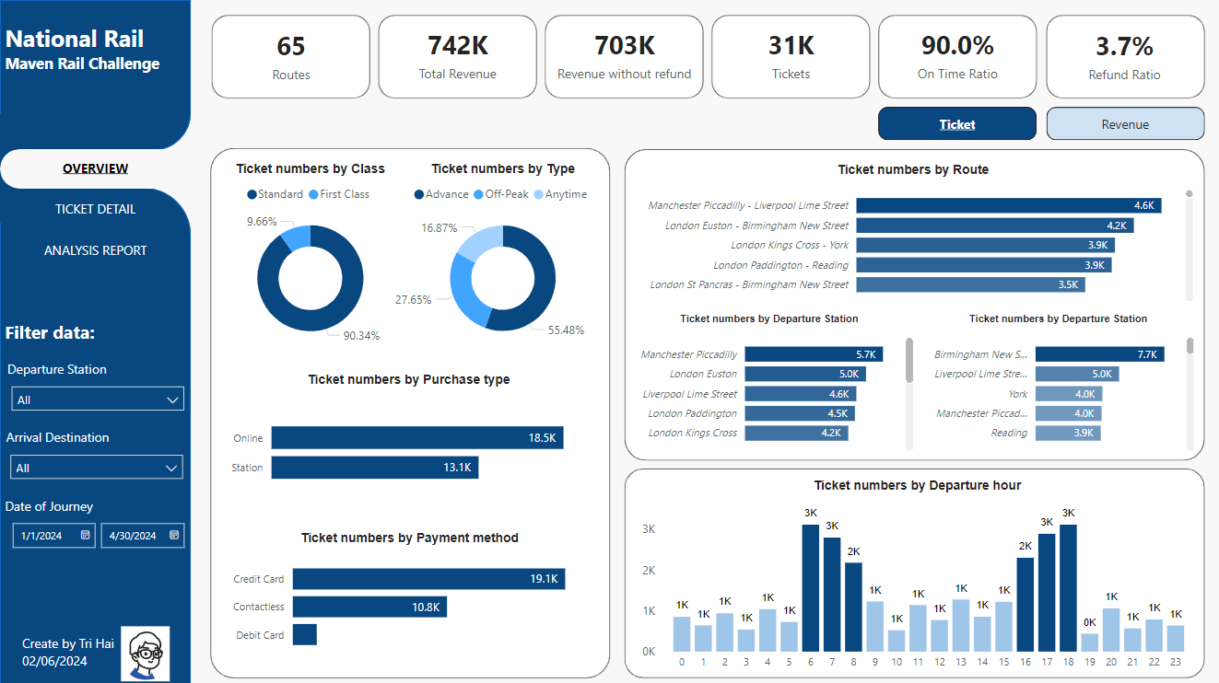

Show overall main metrics such as Routes, Total Revenue, Revenue without refund, Tickets, Ontime Ratio and Refund Ratio

Explanation of Two Main Metrics: **Tickets** and **Revenue**

* **Ticket Class**: Breakdown of the number of tickets sold/revenue by class (e.g., Standard, First Class).
* **Ticket Type:** Analysis of tickets/revenue based on type (e.g., peak, off-peak).
* **Purchase Type**: Distribution of tickets sold/Revenue through various purchase methods (e.g., online, at the station).
* **Payment Method**: Insights into the payment methods used (e.g., credit card, cash).
* **Routes**: Number of tickets sold/revenue for each route.
* **Departure Hours**: Ticket sales/revenue distribution by departure hours, highlighting peak times.

Use the **view button** in the top right corner to switch between the detailed breakdowns of Tickets and Revenue, allowing for a comprehensive analysis of each metric by the specified categories.

**2. TICKET DETAIL PAGE:**

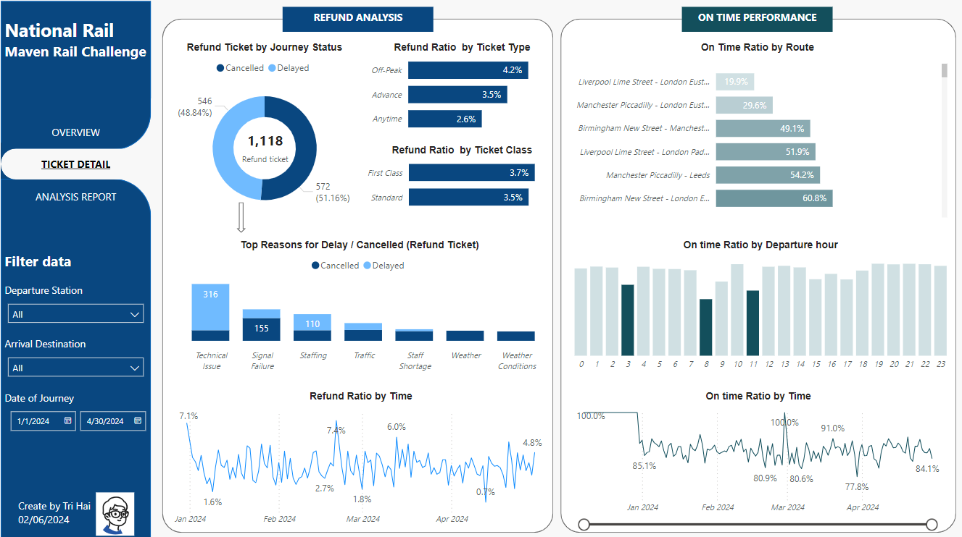  
Focus on two parts: Refunds and On-time Performance, to understand the reasons behind refunded tickets and the low on-time ratio.

**3. ANALYSIS REPORT PAGE:**

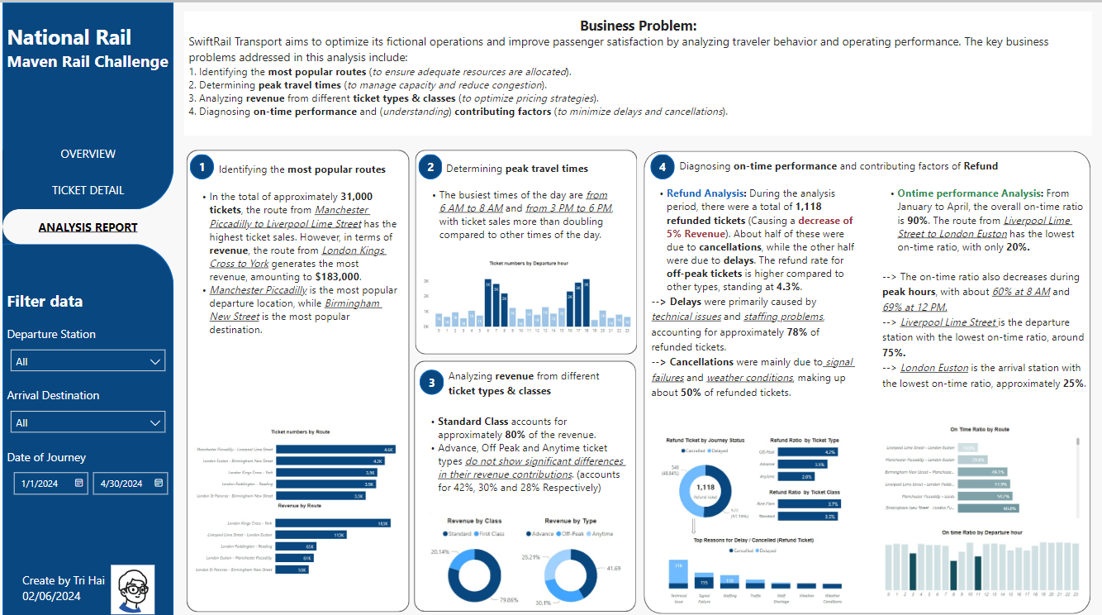Address the questions in the project goals using data from the two previous pages.

**DATA ANALYTIC INSIGHTS:**

**1.** Identifying the **most popular routes**

* In about 31,000 tickets, the route from Manchester Piccadilly to Liverpool Lime Street has the highest ticket sales. However, in terms of **revenue**, the route from *London Kings Cross to York* generates the most revenue, amounting to **$183,000**.
* *Manchester Piccadilly* is the most popular departure location, while *Birmingham New Street* is the most popular destination.

1. Determining **peak travel times**

The busiest times of the day are *from 6 AM to 8 AM* and *from 3 PM to 6 PM*, with ticket sales **more than doubling** compared to other times of the day.

1. Analyzing **revenue** from different **ticket types & classes**

* **Standard Class** accounts for approximately **80%** of the revenue.
* Advance, Off Peak and Anytime ticket types *do not show significant differences in their revenue contributions*. (accounts for **42%**, **30%** and **28%** Respectively)

**4.** Diagnosing **on-time performance** and **contributing factors of Refund**

* **Refund Analysis:** During the analysis period, there were a total of **1,118 refunded tickets** (Causing a **decrease of** **5% Revenue**). About half of these were due to **cancellations**, while the other half were due to **delays**. The refund rate for **off-peak tickets** is higher compared to other types, standing at **4.3%**.
  + **Delays** were primarily caused by *technical issues* and *staffing problems*, accounting for approximately **78%** of refunded tickets.
  + **Cancellations** were mainly due to *signal failures* and *weather conditions*, making up about **50%** of refunded tickets.
* **Ontime performance Analysis:** From January to April, the overall on-time ratio is **90%**. The route from *Liverpool Lime Street to London Euston* has the lowest on-time ratio, with only **20%.**
  + The on-time ratio also decreases during **peak hours**, with about *60% at 8 AM* and *69% at 12 PM.*
  + *Liverpool Lime Street* is the departure station with the lowest on-time ratio, around **75%.**
  + *London Euston* is the arrival station with the lowest on-time ratio, approximately **25%**.

==> Thank you for visiting to the end, for more information about this challenge, you can visit this [link](https://mavenanalytics.io/challenges/maven-rail-challenge/08941141-d23f-4cc9-93a3-4c25ed06e1c3):

---

Tri Hai - 02/06/2024

Contact me at: <https://www.linkedin.com/in/phungtrihai25112000/>